Thermo Shaker—TS100,TSC10
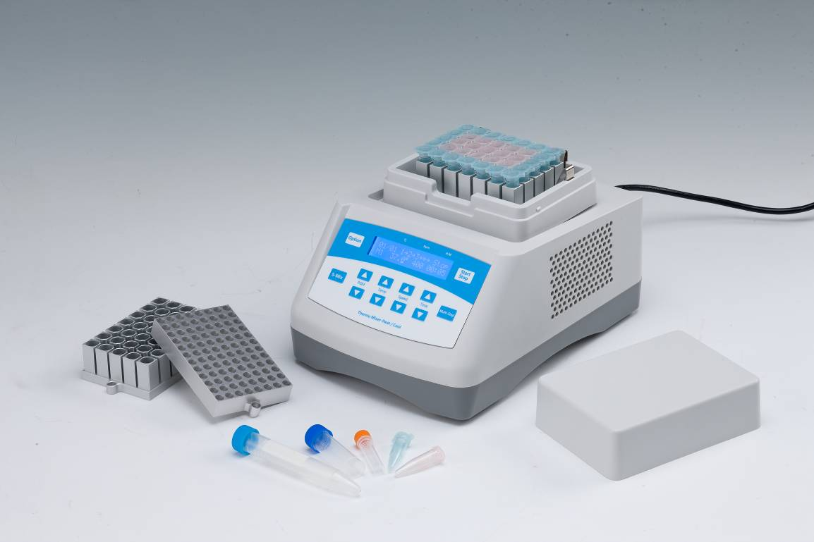
Description:
TS100/TCS10 Thermo Shaker is a temperature controlled shaker, which is useful for a variety of molecular biology applications. Speed, time and temperature settings are continuously visible on the LCD, simultaneously showing both actual and selected values. Integral over-temperature control ensures long time, safety and sample integrity.
Features:
- LCD display. It is easy to setup and use.
- Reliable design with inner extra temperature protection.
- Each device is equipped with lifter that is easy to replace different blocks.
- Digital accuracy and convenience.
- Precision wells for uniform thermal transfer.
- Assorted blocks for a wide variety of tube sizes.
- Brushless DC Motor: noiseless long service life maintenance-free.
- Conforms to CE safety standard.
- Accurately control and display time, temperature and speed.
- 12-month warranty.
Applications:
- Maintaining 14°C for ligation reactions.(TCS10)
- Maintaining 17°C for storing oocytes.(TCS10)
- Storing samples at ice bucket temperatures.
- Storing enzymes or DNA libraries at your work station.
- Transporting samples from the field at exactly the right temperature.
- Heating samples in the field.
- Enzyme reactions and deactivations.
- PCR sample preparation.
Parameters:
Model | TS100 | TCS10
Temp setting range | 0℃~100℃ | 0℃~100℃
Temp control range | RT+5℃~100℃ | RT.-20℃~100℃
Time range | 1min ~ 99h59min/∞ | 1min ~ 99h59min/∞
Temp accuracy | ≤±0.3℃* | ≤±0.3℃*
Display accuracy | 0.1℃ | 0.1℃
Temp uniformity | ≤±0.3℃* | ≤±0.3℃*
Speed range | 200~1800rpm | 200~1500rpm
Orbit | 3mm | 3mm
Heating time | ≤12min(from 25℃ to 100℃)* | ≤15min(from 25℃ to 100℃)*
Cooling time1 |  | ≤10min(from 100℃ to 25℃)*
Cooling time2 |  | ≤20min(from RT. to RT.-20℃)*
Multi point running | Yes(Max 5points) | Yes(Max 5points)
Multi cycle | Yes(Max 99times)  ） | Yes(Max 99times)
Auto heating | Yes | Yes
Auto running | Yes | Yes
Auto resume to run | Yes | Yes
Storage at 4℃ |  | Yes
Power supply | 150W | 150W
Voltage | AC220V or AC110V/50-60Hz | AC110V~220V/50-60Hz
Fuse | 250V 3A Ф5×20 | 250V 3A Ф5×20
Dimension(mm) | 260x195x150 | 260x195x150
Weight | 7.5kg | 7.0kg
Type | Capacity | Temp range | Max Speed (TS100) | Max Speed (TCS10)
MD30 | 96x0.2ml | 0℃~100℃ | 1800rpm | 1500rpm
MD31 | 54x0.5ml | 0℃~100℃ | 1800rpm | 1500rpm
MD32 | 35x1.5ml | 0℃~100℃ | 1800rpm | 1500rpm
MD33 | 35x2.0ml | 0℃~100℃ | 1800rpm | 1500rpm
MD34 | 20x1.5ml+15x0.5ml | 0℃~100℃ | 1800rpm | 1500rpm
MD35 | 96x0.2ml | 0℃~100℃ | 1800rpm | 1500rpm
MD36 | 24x5ml | 0℃~100℃ | 1000rpm | 1000rpm
MD37 | 15x10ml | 0℃~100℃ | 1000rpm | 1000rpm
MD38 | 12x15ml | 0℃~100℃ | 1000rpm | 800rpm
MD39 | 6x50ml | 0℃~100℃ | 800rpm | 800rpm
Optional Blocks:

